AI Usage Proof Submission – GitHub Copilot Assisted Frontend Development

Submitted By
Amit
Senior Software Engineer – Frontend (React)

1. Objective
This document provides formal evidence of practical AI adoption in my day-to-day engineering workflow using GitHub Copilot. The goal is to demonstrate how AI is actively improving development speed, code quality, and delivery efficiency in real project scenarios.

2. Use Case Overview
For this proof case, I selected an epic in ClickUp containing multiple frontend stories. Two closely related UI stories were identified and implemented together.

Inputs used with AI
- ClickUp story requirements
- Figma design references
- Existing project coding style expectations
- Best coding practices and reusable architecture guidelines
Supporting evidence attached:
- Screenshot of ClickUp stories
- Screenshot of Figma design
- Screenshot of prompt shared with GitHub Copilot
- Screenshot of Copilot response
- Screenshot of generated UI
- Screen recording of the complete workflow

3. AI-Assisted Workflow

Step 1 – Requirement Analysis
- Reviewed the epic and selected two related UI stories
- Analyzed Figma designs for layout and interaction expectations
- Combined the related requirements into a single implementation workflow
- Below is the screen shot of clickup and figma design

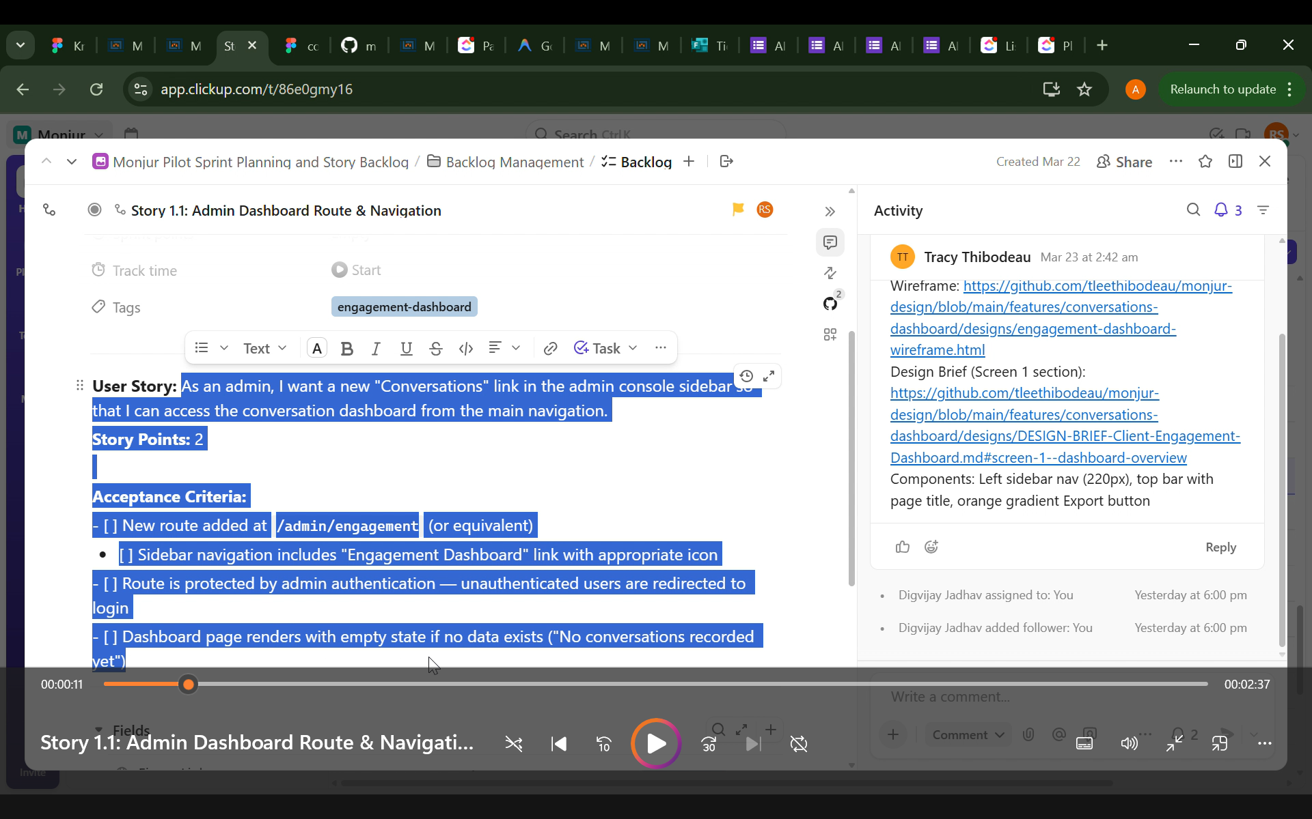
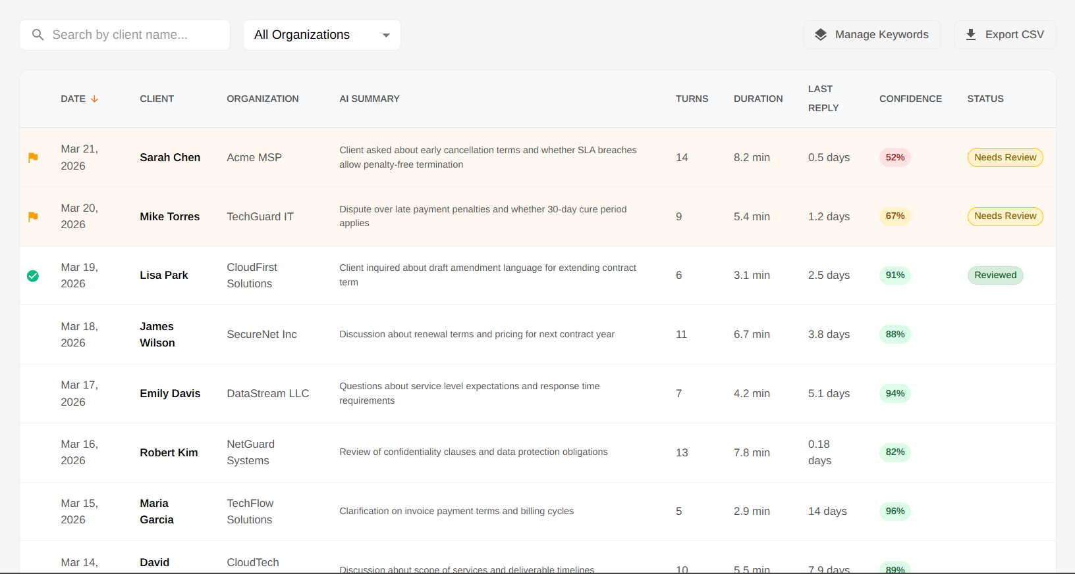

Step 2 – Prompt Engineering with GitHub Copilot
The selected stories, Figma references, and coding expectations were provided to GitHub Copilot Chat with instructions to:
- follow project coding standards
- use best frontend coding practices
- create reusable and scalable React components
- align closely with Figma design

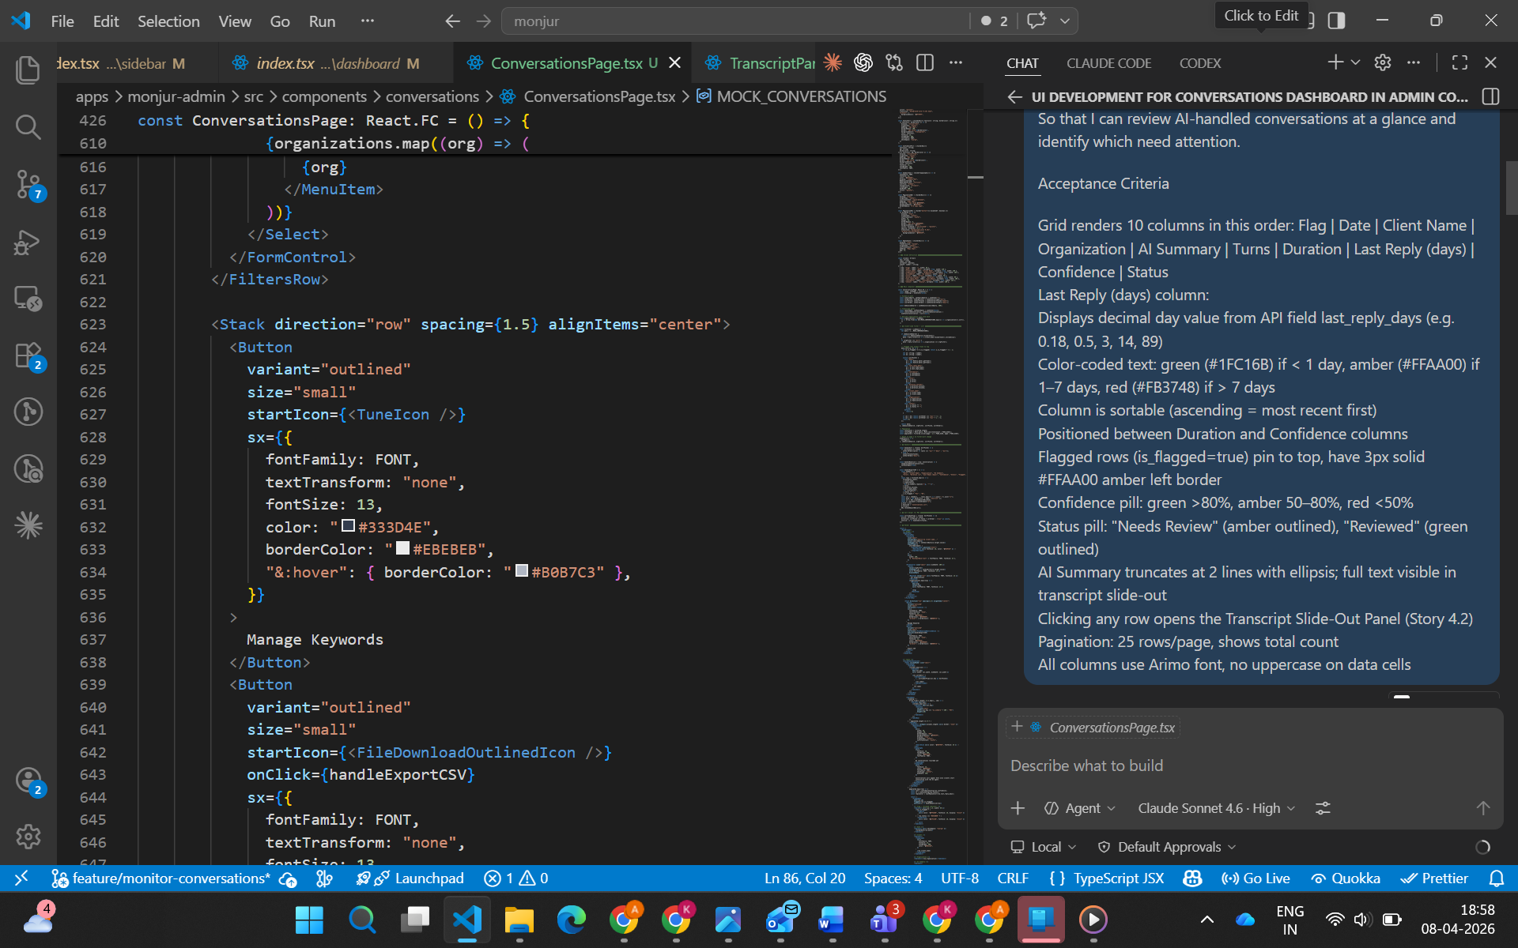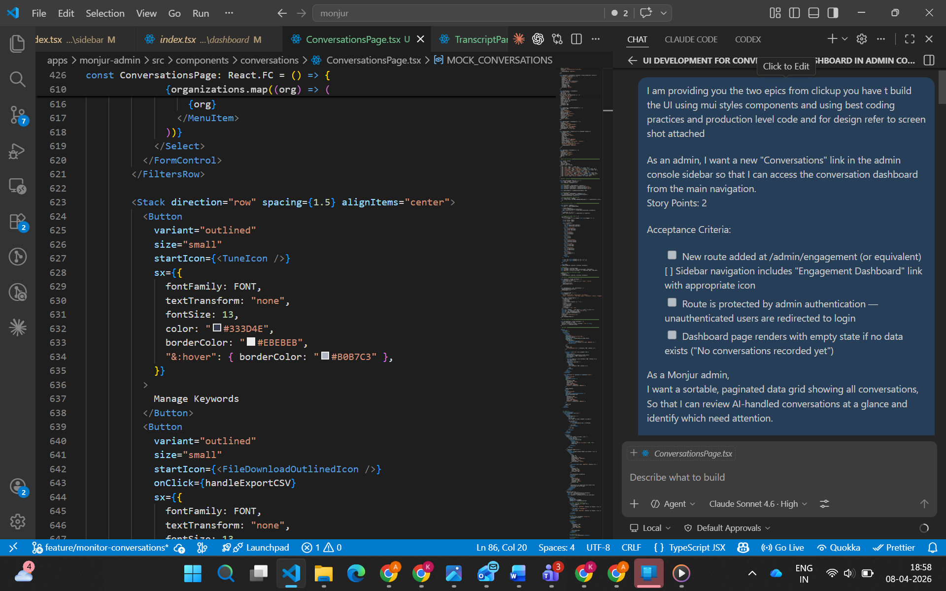

Step 3 – Rapid UI Generation
Within 5–10 minutes, Copilot generated:
- component structure
- reusable UI sections
- interaction scaffolding
- TypeScript-ready component patterns
- clean layout aligned with design references

Step 4 – Mock Data Enablement
Since backend APIs for this feature were not yet available, Copilot was further instructed to use mock data temporarily.
This enabled:
- immediate UI rendering
- design validation
- faster internal review
- early stakeholder visibility
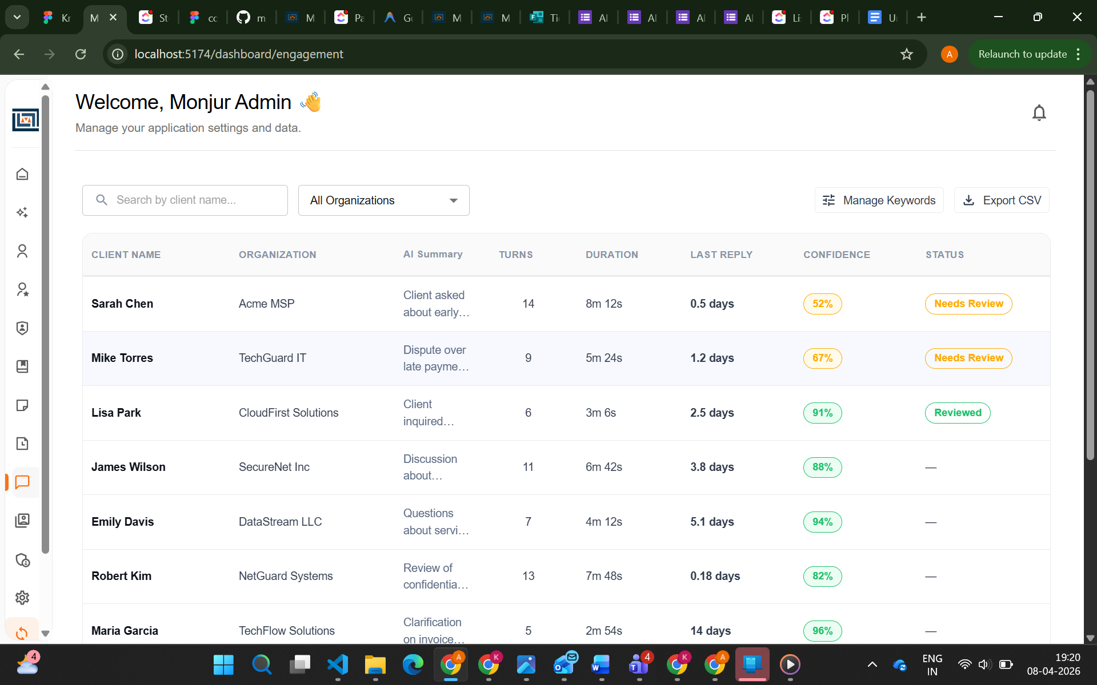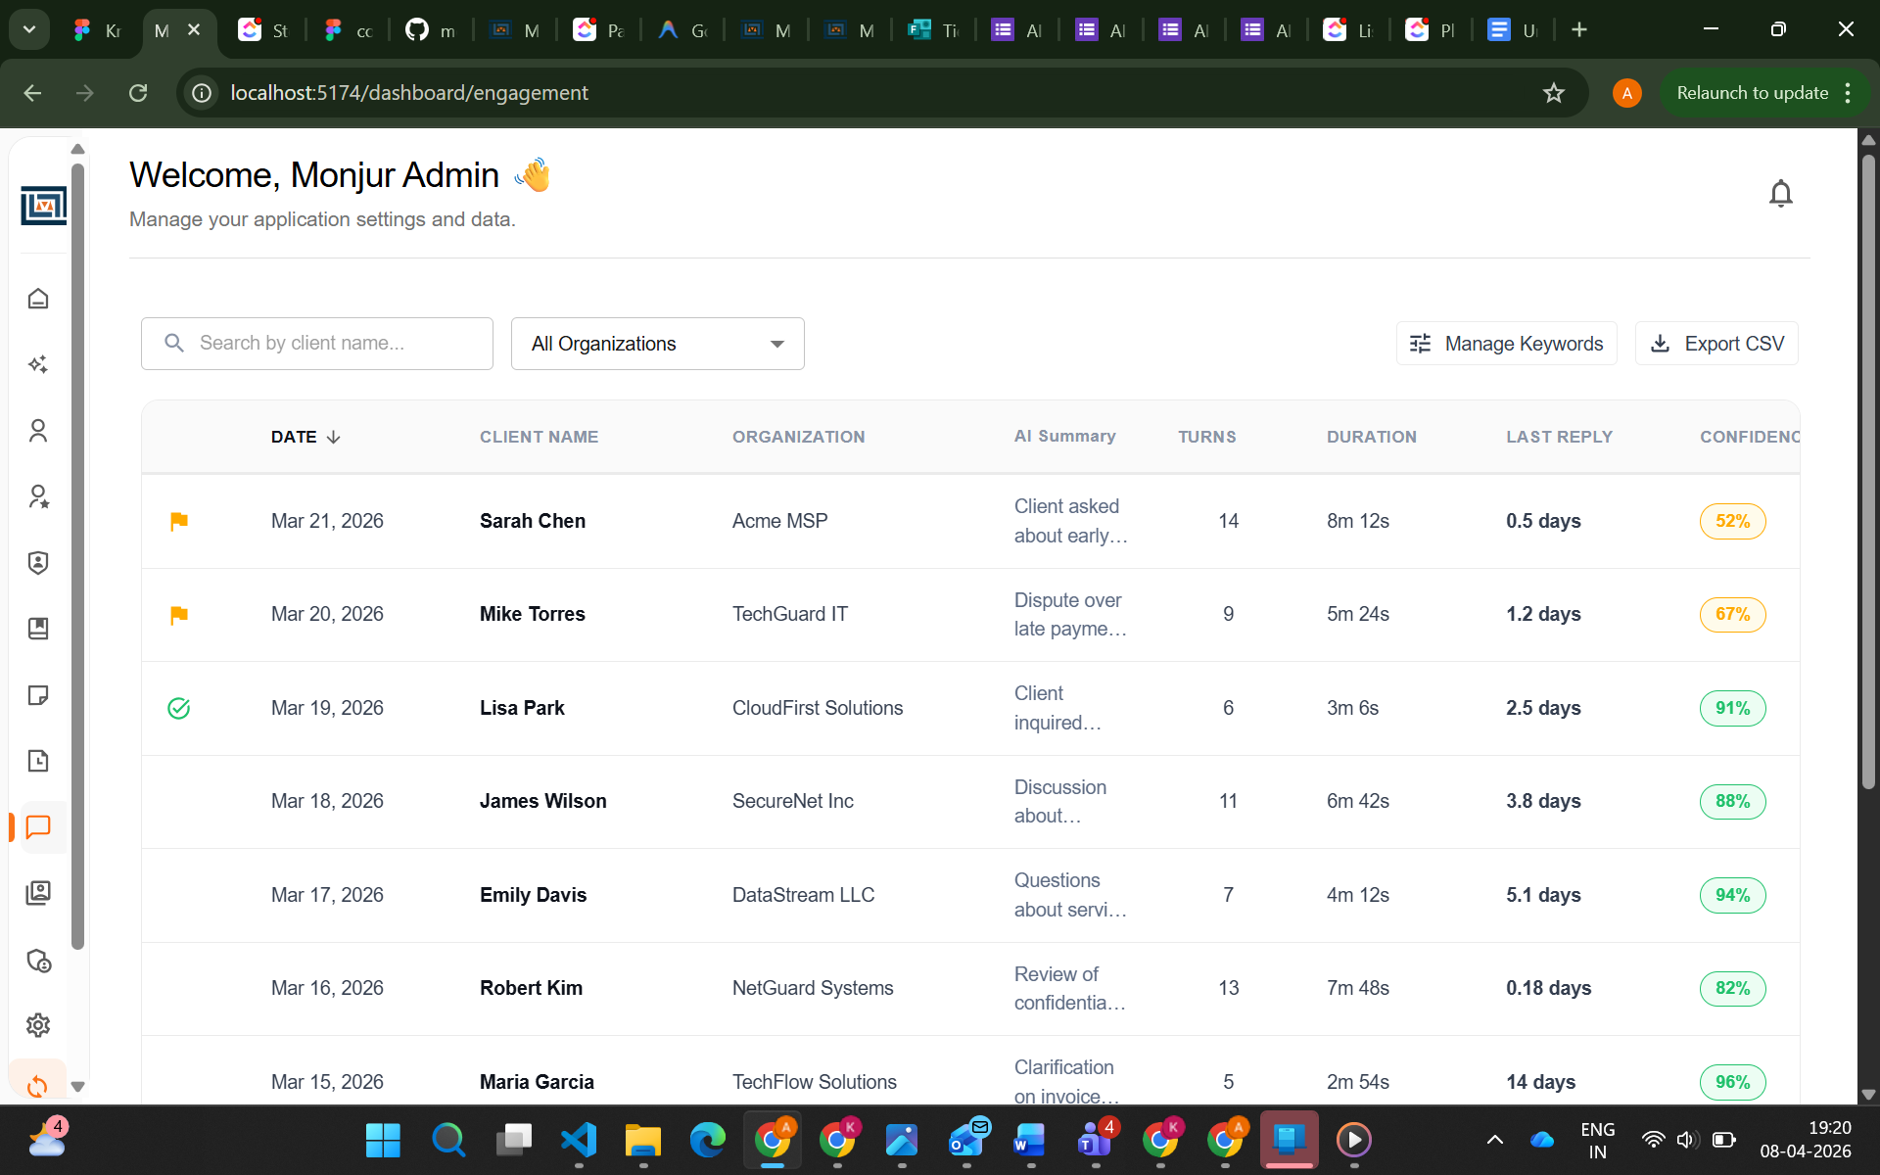

4. Measurable Productivity Impact

AI-Assisted Delivery Time
Less than 25 minutes

Estimated Manual Delivery Time
6–8 hours

Estimated Productivity Gain
70–80% reduction in implementation time
This time saving was achieved through:
- rapid component scaffolding
- reduced boilerplate effort
- faster layout creation
- quick mock data simulation
- early UI visualization before API readiness

5. Business ROI
The use of AI in this task directly contributed to:
- Faster ticket turnaround time
- Improved sprint execution speed
- Reduced repetitive coding effort
- Early design validation before backend readiness
- Better developer productivity
- Faster iteration cycles for UI refinement
This approach significantly accelerates the transition from requirement → prototype → production refinement.

6. Current Status and Next Steps
The generated UI is currently in a strong functional state using mock data.
Next steps include:
- pixel-perfect refinement as per Figma
- production-grade styling polish
- real API integration once backend endpoints are available
- final QA and responsiveness validation

7. Conclusion
This use case demonstrates practical, measurable, and high-impact AI adoption in frontend engineering workflows. Here is the link of the screen recording for reference: video link
GitHub Copilot was effectively used for:
- requirement translation
- UI scaffolding
- component architecture
- mock data simulation
- rapid prototyping
The result was a working UI delivered in under 30 minutes, compared to an estimated 6–8 hours manually, clearly proving strong ROI and productivity improvement through AI-assisted development.

